ASSIGNMENT - 1

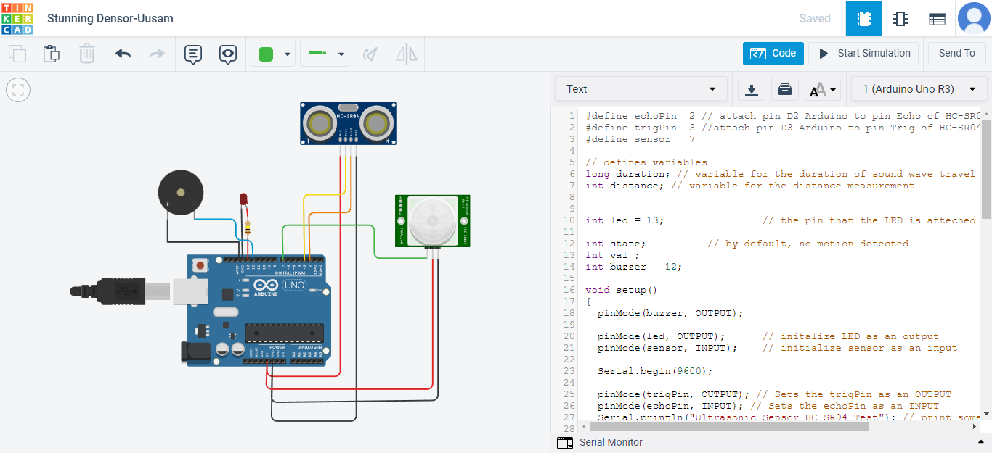

## SUBMITTED BY

# MANORAJ